dbms2526_storage.pdf, which covers the Storage and Sorting lecture of Implementation of DBMS (Prof. Klingemann, WS 25/26).

🧾 Summary: DBMS Storage and Sorting

🔹 1. Storage Hierarchy

Primary Storage
- Components: CPU cache, main memory (RAM)
- Speed: ~50 GB/s, latency ~100 ns
- Volatile: data lost on power-off
- Access: byte-level, random access
- Used for: buffers and temporary computation

Secondary Storage
- Components: HDDs, SSDs
- Non-volatile, persistent, large capacity
- Block-based access (≈4 KB typical block)
- Slower:
  - HDD: 280 MB/s, latency 1–30 ms
  - SSD: up to 7000 MB/s, latency 10–100 µs
- Key design needs:
  - Buffer management (caching)
  - Efficient query & I/O scheduling

Tertiary Storage
- Media: Magnetic tapes, optical disks
- Use: Long-term archives, backups, logs
- Offline and very slow (manual intervention)
- Capacity: TBs per tape

🔹 2. HDD vs SSD
Feature | HDD | SSD
Speed | Slower | Faster
Cost | Cheaper | More expensive
Reliability | Moving parts (wear) | Limited write cycles
Usage | Large DBs | OS, caching, smaller data
2024 stats: sold capacity of HDDs ≈ 3× SSDs.

🔹 3. Performance Metrics
- DBMS performance bottleneck = I/O between memory and disk.
- Data moves in blocks (≈4 KB).
- Disk I/O = expensive operation → measured as the main cost metric.
  - 1 random disk I/O ≈ time for 1 million CPU instructions.
- Optimization goals:
  - Use every read block fully.
  - Store related blocks physically close.
  - Keep frequently used blocks buffered.

🔹 4. Sorting in DBMS

Why not normal in-memory sort?
Because reading/writing to disk dominates runtime.
Hence, disk-efficient sorts like Merge Sort are used.

🔹 5. Merge Sort (Basics)
Algorithm:
- Divide file into parts (runs)
- Sort each run in main memory
- Merge sorted runs repeatedly
But recursive merge sort → too many passes (≈log₂N).

🔹 6. Two-Phase Multiway Merge Sort (2PMMS)

Goal:
Reduce I/O passes to only two.

Phase 1 – Create Sorted Runs
- Load M blocks into memory.
- Sort them (any in-memory sort).
- Write sorted sublist (run) to disk.
- Repeat until all records processed.

Phase 2 – Merge Runs
- Use (M – 1) input buffers (one per run) + 1 output buffer.
- Read the first block of each run.
- Repeatedly output the smallest record among buffers.
- Replace exhausted blocks as needed.
- Write output when full.

I/O Cost
Each block is:
- Read once in Phase 1
- Written once in Phase 1
- Read once in Phase 2
- Written once in Phase 2
Total I/Os = 4 × B
(where B = total blocks of the file)

Example:
- File = 10⁷ records × 100 bytes = 10⁹ bytes
- Block size = 4 KB → 250,000 blocks
- Memory = 50 MB → 12,800 blocks
- Cost = 4 × 250,000 = 1,000,000 I/Os

🔹 7. Formula: Max Records Sortable in 2PMMS
Let:
- B = block size (bytes)
- M = memory size (bytes)
- R = record size (bytes)
Then:
- Buffers = M / B
- Sorted sublists = (M / B) – 1
- Records per sublist = M / R
- Total records sortable in 2PMMS:
If N > Nmax → need a third pass (multi-pass merge).

🧠 CHEAT SHEET: DBMS STORAGE & SORTING
Topic | Key Concept / Formula
Primary Storage | Main memory, volatile, byte-level, 100 ns latency
Secondary Storage | HDD/SSD, non-volatile, block-based, ms/µs latency
Tertiary Storage | Tape/discs, offline archival
Disk I/O Cost | 1 random I/O ≈ 1 million CPU instructions
DBMS Performance | Minimize I/Os, maximize buffer reuse
Merge Sort | Divide + sort + merge (many passes)
2PMMS Phase 1 | Sort runs of M blocks in memory
2PMMS Phase 2 | Merge up to (M–1) runs using buffers
I/O Cost (2PMMS) | 4 × B (each block read/written twice)
#Runs (Phase 1) | = ceil(B / M)
Sortable Records in 2 Passes | ≈ M² / (R × B)
If N > Nmax | Need ≥ 3 passes
Optimize I/O | Sequential access, clustering, caching

💡 Quick Tips for Exam:
- Always express cost in I/Os, not time.
- Remember: 2PMMS = 2 passes, 4B I/Os.
- Memory limits the number of runs merged in one go.
- Larger block or memory size → fewer runs → fewer I/Os.
- Formula to remember:
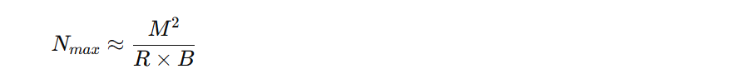
- Be ready to compute:
  - #blocks = T(R) / (block capacity)
  - #runs = ceil(B / M)
  - Total I/Os = 4B

🧾 DBMS Storage & Sorting — Exam Cheat Sheet

⚙️ 1. Storage Hierarchy Overview
Level | Example | Access | Typical Use | Notes
Primary | CPU cache, RAM | Byte-level | Buffers, temp results | Fast, volatile
Secondary | HDD, SSD | Block-level (4 KB) | DB files | Persistent, slower
Tertiary | Tape, optical | Sequential | Backup, archive | Very slow
🔸 I/O = dominant cost in DBMS — goal is to minimize it.

⚡ 2. Disk & I/O Facts
- Block size (B): 4 KB (≈ 4096 bytes)
- Records per block: ⌊ B / record size ⌋
- Disk I/O time ≫ CPU time
→ 1 random I/O ≈ 1 million CPU instructions
- Sequential access ≫ random access
- Optimization: cluster related records, reuse buffers.

🧮 3. Merge Sort Concepts

🟢 Standard Merge Sort
- Split file into runs
- Sort each run in memory
- Merge repeatedly (many passes)

🔵 Two-Phase Multiway Merge Sort (2PMMS)
Goal: sort entire file in only two passes.

Phase 1 — Create Runs
- Load M blocks into memory
- Sort them (any in-memory algorithm)
- Write each sorted run back to disk

Phase 2 — Merge Runs
- Use M – 1 input buffers (one per run) + 1 output buffer
- Merge all runs at once into final sorted file

📊 4. Key Formulas

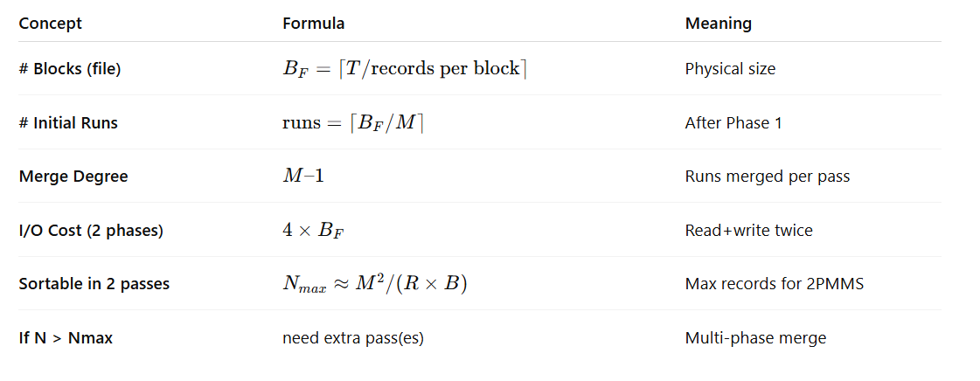

🧩 5. Example Calculation
File: 1 000 000 records × 100 B = 100 MB
Block = 4 KB → 25 records/block → 40 000 blocks
Memory = 500 KB = 125 blocks
Phase 1: #runs = 40 000 / 125 = 320
Phase 2: can merge 124 runs → needs 3 passes
Each pass = 2B I/Os → Total = 6B ≈ 240 000 I/Os

🔍 6. Performance Insights
Parameter | ↑ Effect
Block size ↑ | fewer I/Os
Memory ↑ | fewer runs, often 2-phase possible
Sequential layout | faster I/O
Clustered index | contiguous access ⇒ fewer reads
Unclustered index | random I/O ⇒ higher cost

🧠 7. Quick Recall for Exam
- I/O = key metric, ignore CPU cost.
- 2PMMS Cost = 4 B (read+write twice).
- Max records in 2 passes: ( M^2 / (R × B) ).
- #runs = ceil(B / M).
- Always check if M – 1 ≥ #runs → if yes, only 2 phases.
- If not, compute extra passes:
passes = 1 + ⌈\log_{M-1}( \text{#runs} )⌉
- Bigger M or B = fewer I/Os.

🧩 8. Exam Quick-Answer Template
Given: T, R, B, M
→ Compute:
1️⃣ records/block = B/R
2️⃣ blocks = T / (records/block)
3️⃣ runs = ceil(blocks / M)
4️⃣ I/Os = 4 × blocks (if 2 phases)
5️⃣ Check Nmax ≈ M² / (R × B)

✅ Pro-tip:
If your file fits in memory (B ≤ M) → only 1 pass (read, sort, write).
If #runs ≤ M – 1 → 2 passes (optimal).
Otherwise → extra merges; each adds 2 × B I/Os.

